1) OAKVILLE * TUESDAYS * WATER’S EDGE FITNESS

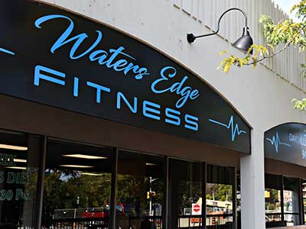
We meet inside Water’s Edge Fitness - The club is located at 11 Lakeshore Rd West, just west of Forsythe St. in downtown Oakville, just a short jog away from our Forster Park loop training grounds! Click here for more info and/or map

Parking: Paid street parking available nearby

Facilities: Washrooms/changerooms available, no shower privileges

Instructions: Upon arrival (ideally by 6:25pm) please check in with head coach, confirm work-out details, and start group warm up by 6:35.

2 WEST TORONTO * WEDNESDAYS * HIGH PARK
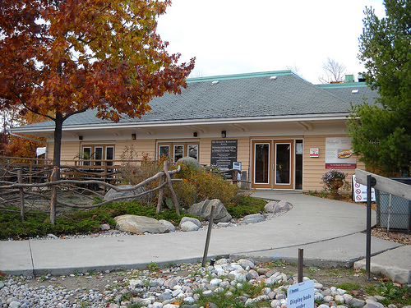
We meet inside the Grenadier Restaurant in the center of High Park. If west of the Parkside/Keele intersection). Click here for map (zoom in)

Follow the main, one way road (West Rd.) exactly 1km, where you should see Grenadier Restaurant on your left. There’s lots of (free) parking available right there. Once inside, proceed to the left, where our group gathers.

There are washrooms available (you can change there if needed, though still best to arrive ready to run if possible).

Evening group - we meet/organize from 6:30-6:40pm, then group warm up starts at 6:40pm.

3 & 4) EAST TORONTO * THURSDAYS * MONARCH PARK STADIUM

We meet at Monarch Park Stadium, Toronto’s largest INDOOR track facility, located 1 block south of Danforth/Coxwell. Free parking! Click here for map
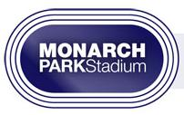
NB - Full changeroom, washroom, showers and lockers available for 2015.

* Due to the very busy conditions and the need to change clothes, we ask that runners in the evening group arrive by 6:20pm, so they can begin their warm up by 6:30pm sharp. We congregate/make announcements at 6:45, and then complete the warm up, and begin our workout before 7pm.

The early morning group should arrive by 5:55am to start their warm up by 6am sharp.

Please note: All users of the MP indoor track must pay a user fee.

It’s most economical (for those only planning on using the facility once per week) to choose either a special Marathon Dynamics full season pass, or a “10 pack” or “20 pack” pass. You can purchase these passes online before your first visit. Otherwise, you will be charged the per diem rate of $10/visit.
Click here for more info on the fees for Monarch Park track.

