1) OAKVILLE * TUESDAYS * PHYSICAL EDGE PHYSIO

We meet inside Physical Edge physio - located at 581 Argus Rd. (near Trafalgar GO station). Click here for map.

Coach: Kevin Smith (check “about us” on MDI website for bios/pics)

Parking: free lot parking available after 6pm

Facilities: Washrooms/changerooms available, no shower privileges

Instructions: Upon arrival (ideally by 6:25pm) please check in with head coach, confirm work-out details, and start group warm up by 6:30-6:35.

2 WEST TORONTO * WEDNESDAYS * HIGH PARK
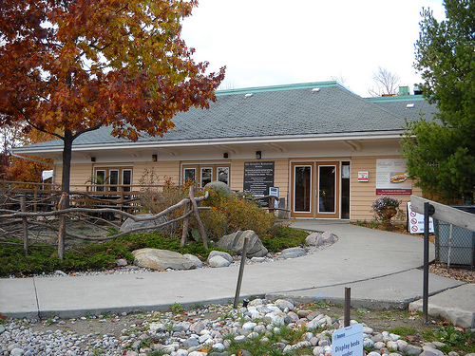
We meet inside the Grenadier Restaurant in the center of High Park. If west of the Parkside/Keele intersection). Click here for map (zoom in)

Follow the main, one way road (West Rd.) exactly 1km, where you should see Grenadier Restaurant on your left. There’s lots of (free) parking available right there. Once inside, proceed to the left, where our group gathers.

There are washrooms available (you can change there if needed, though still best to arrive ready to run if possible).

Evening group - we meet/organize from 6:30-6:40pm, then group warm up starts at 6:40pm.

3 & 5) EAST TORONTO * THURSDAYS * MONARCH PARK STADIUM

We meet at Monarch Park Stadium, Toronto’s newest and largest INDOOR track facility, located 1 block south of Danforth/Coxwell. Free parking! Click here for map
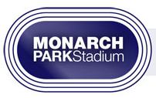
NB - Full changeroom, washroom, showers and lockers available for 2015.

* Due to the very busy conditions and the need to change clothes, we ask that runners in the evening group arrive by 6:20pm, so they can begin their warm up by 6:30pm sharp. We congregate/make announcements at 6:45, and then complete the warm up, and begin our workout before 7pm.

The early morning group should arrive by 5:55am to start their warm up by 6am sharp.

Please note: All users of the MP indoor track must pay a user fee.

It’s most economical (for those only planning on using the facility once per week) to choose special “10 Pack” rate that MDI has arranged, for $81 (about $8 per visit). You can purchase these passes upon your first arrival at the front desk. If you plan on using the facility more frequently, then we suggest you consider a monthly pass instead. Click here for more info on the fees for Monarch Park track.

4) UPTOWN GROUP * 9:30AM - THURSDAYS * TOTUM LIFE SCIENCE
We meet at Totum Life Science, 2 Roxborough St. E (corner of Yonge and Roxborough, 3-4 blocks south of Summerhill Subway. Click here for map.

NB - Full change and washroom facilities are available, but best to arrive ready to run if at all possible.

Usually meet just inside the front doors, to congregate/make announcements from 9:25-9:30am. The group warm up starts at 9:35am to our various workout locations nearby. If arriving late (after 9:35am), check with the Totum staff to find out where we’ve gone so you can find us.
Totum front desk phone # - 416 925- 5706

